Comparing Simple Machines
- Complete the statements in the table below and draw a diagram to demonstrate the type of lever the statements describes.

Statement | Diagram
The ……………………. is between the ……………………. and the load in a
first-class lever.
The ……………………. is between the ……………………. and the ……………………. in a second-class lever.
The ……………………. is between the ……………………. and the ……………………. in a third-class lever.
- In each of the cases below, state whether the example is of a speed multiplier or a force multiplier. Also state what type of machine the example represents.

Example | Force multiplier (FM) or speed multiplier (SM)? | Type of machine
A cricket bat
A hammer removing a nail
A ramp into the shops
The wheel on a car
A block and tackle on a ship
A ceiling fan

- Show all your working for the following problems.
- What is the mechanical advantage of the shovel if the soil weighs 12.5 N and the effort of the hand on the handle is 2.5 N?
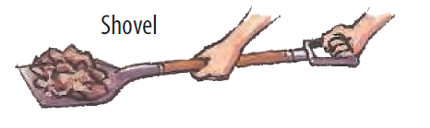
(b) To increase the mechanical advantage of this lever, which way should the person move their hand and why?
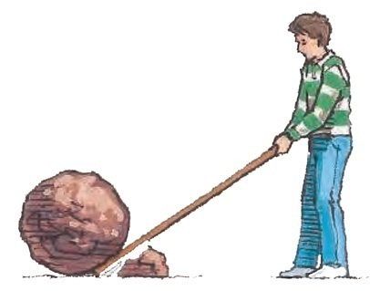
- How much effort is needed to move a rock weighing 55 N with a crowbar that has a mechanical advantage of 4.4? Show all your working and label the fulcrum, effort, and load on the diagram above.

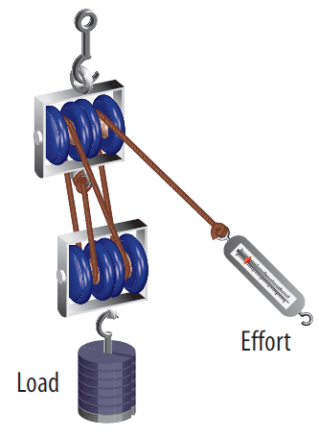
- Work out the mechanical advantage of the pulley below. Then calculate what the load on the pulley, in N is. The effort made is 160 N. Show all your working.

- In the table below, list the advantages and disadvantages of a winding road or footpath as opposed to a straight road or footpath up the side of a steep mountain.

 | Advantages | Disadvantages
Winding road
Straight road

- Screws and nails are both simple machines. Complete the Venn diagram below to compare the two.
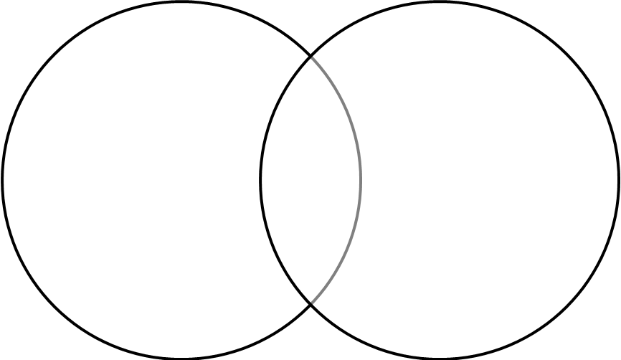

- The image below shows some of the work involved in building a medieval castle.
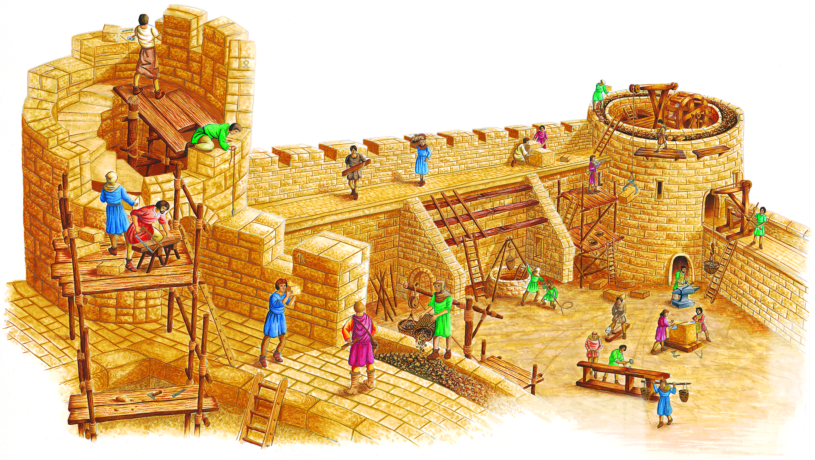
- Define the term ‘compound machine’.

(b) Circle all the simple machines you can find.
(c) In the table below, list three machines found in the illustration and explain how they make the job of building the castle easier. Also state how the job might be achieved if that simple machine was absent.

Type of machine | Explanation | How job would be achieved if machine was absent
(d) Add your own simple machine to the diagram to further assist the building of the castle. Briefly describe how your simple machine helps in building the castle.

